Asymmetric DCC correlation: EURUSD and GBPUSD
Method 10 / GARCH(1,1) + Cappiello-Engle-Sheppard ADCC / Alpari D1 full available history

Study setup
Logical pair: EURUSD , GBPUSD
Broker symbols: EURUSD_i , GBPUSD_i
Snapshot: 2026-11-03_majors_alpari_D1
Timeframe: D1
Matched return window: 1999-01-05 to 2026-11-02 (UTC bar dates)
Matched return count n: 7202
Dropped unfinished last bar dated 2026-11-03 UTC after a tick-volume check against the prior complete day.
EURUSD GARCH(1,1): mu=0.000010, omega=0.001152, alpha=0.036679, beta=0.960040
GBPUSD GARCH(1,1): mu=0.000018, omega=0.004029, alpha=0.055460, beta=0.932146
ADCC: a=0.023020, b=0.974614, g=0.001110, a+b+g/2=0.998188
Nested DCC (g=0): a=0.023581, b=0.974449
Negative shock: n = min(z, 0) in broker quote direction (not inverted)
Burn-in ignored in path summaries and chart: first 60 updates
Complete matched rows (Excel): EURUSD-GBPUSD_ADCC_D1.xlsx
Complete matched rows (HTML table): EURUSD-GBPUSD_ADCC_D1_data.html

Method carried forward
Asymmetric DCC extends Engle DCC with an extra term on joint negative standardised shocks. Each matched daily log return of close, ln(close_t / close_t-1), is first filtered by a constant-mean GARCH(1,1). Then z = residual / sigma and n = min(z, 0). The Cappiello-Engle-Sheppard recursion uses A = (1-a-b) Q_bar - g N_bar with N_bar = mean(n n'). Quotes are not inverted, so a negative shock is a negative log return in the broker quote. Nested symmetric DCC (g = 0) is fit on the same z path for comparison. Constraints: a,b,g >= 0 and a + b + g/2 < 1. Path summaries ignore the first 60 updates. The headline is latest ADCC rho. Pearson r is a side check only. This is not a cause, lead, or trading signal.

Results
Latest ADCC rho: 0.838990
Latest nested DCC rho: 0.837699
Post-burn-in ADCC path (n=7142): mean=0.655551, median=0.667830, min=0.161243, max=0.878665, std=0.124745
Share of post-burn-in days with |rho| >= 0.4: 96.01%; |rho| >= 0.7: 40.76%
Same-sample Pearson r: 0.641738
ADCC minus r: 0.197252
ADCC minus nested DCC: 0.001292

Conclusion
Over 7202 matched daily log-return rows for EURUSD and GBPUSD (broker quote directions unchanged), latest ADCC rho is 0.8390 (positive, strong conditional linear link in this sample) with fitted a=0.0230, b=0.9746, g=0.0011. Nested symmetric DCC latest rho is 0.8377 (ADCC minus DCC = 0.0013). After a 60-day burn-in, path mean is 0.6556 and std is 0.1247. Same-sample Pearson r is 0.6417 (ADCC minus r = 0.1973). This does not establish cause, lead-lag, or a lasting trading rule.

Charts
Daily closes

Daily log returns
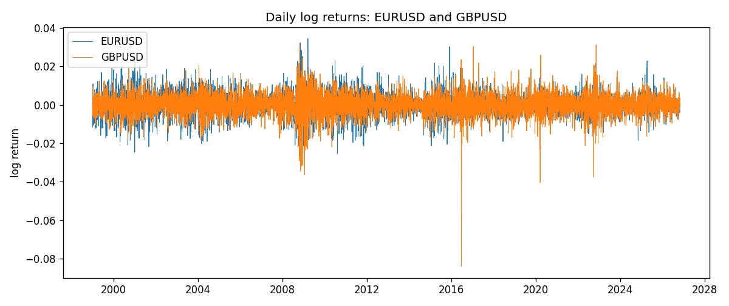
ADCC rho path with nested DCC and Pearson r
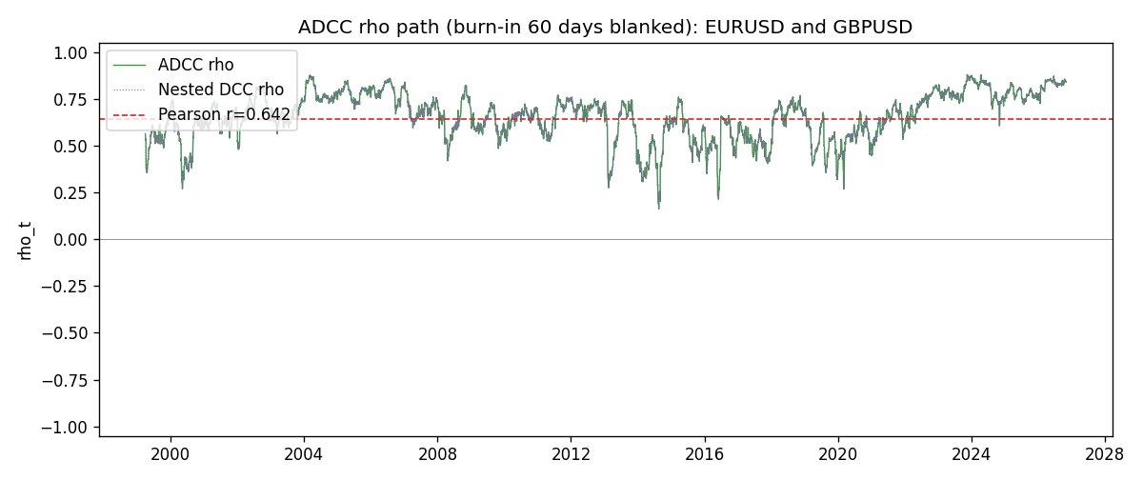

Data report
Every matched row that entered the ADCC recursion is stored in the sibling Excel workbook named EURUSD-GBPUSD_ADCC_D1.xlsx. Embedding all rows as a Word table is impractical at this length; the Word file holds the column list, column summaries, and the first and last 15 matched rows.
Columns: time, EURUSD_open, GBPUSD_open, EURUSD_high, GBPUSD_high, EURUSD_low, GBPUSD_low, EURUSD_close, GBPUSD_close, EURUSD_tick_volume, GBPUSD_tick_volume, EURUSD_spread, GBPUSD_spread, EURUSD_real_volume, GBPUSD_real_volume, EURUSD_log_return, GBPUSD_log_return, EURUSD_sigma, GBPUSD_sigma, EURUSD_z, GBPUSD_z, EURUSD_n, GBPUSD_n, q11, q22, q12, rho_adcc, rho_dcc
Column summaries (matched calculation rows)
column | count | mean | std | min | 25% | 50% | 75% | max
EURUSD_open | 7202 | 1.1812936 | 0.15087968 | 0.8272 | 1.086065 | 1.166145 | 1.293925 | 1.5995
GBPUSD_open | 7202 | 1.5160822 | 0.2182507 | 1.06854 | 1.325005 | 1.51141 | 1.63166 | 2.1066
EURUSD_high | 7202 | 1.1864255 | 0.15147858 | 0.8326 | 1.0901775 | 1.17127 | 1.2992275 | 1.6038
GBPUSD_high | 7202 | 1.5223773 | 0.21881719 | 1.08366 | 1.329795 | 1.51815 | 1.63839 | 2.1161
EURUSD_low | 7202 | 1.1762813 | 0.15020267 | 0.8227 | 1.0819975 | 1.162535 | 1.288315 | 1.5865
GBPUSD_low | 7202 | 1.5097565 | 0.21747799 | 1.03518 | 1.3195075 | 1.503295 | 1.6243825 | 2.0983
EURUSD_close | 7202 | 1.1813323 | 0.15085599 | 0.8267 | 1.0860025 | 1.166105 | 1.2939475 | 1.5997
GBPUSD_close | 7202 | 1.5161468 | 0.21820921 | 1.06879 | 1.325125 | 1.511325 | 1.632095 | 2.1065
EURUSD_tick_volume | 7202 | 102990.53 | 173401.83 | 218 | 9388.25 | 52708 | 99433.75 | 1471626
GBPUSD_tick_volume | 7202 | 94813.509 | 153540.37 | 62 | 9988.5 | 52886.5 | 91789.25 | 1273370
EURUSD_spread | 7202 | 19.400444 | 16.577153 | 0 | 8 | 12 | 30 | 50
GBPUSD_spread | 7202 | 26.974313 | 19.194125 | 0 | 11 | 20 | 50 | 50
EURUSD_real_volume | 7202 | 4.0233049e+10 | 1.6674277e+11 | 0 | 0 | 0 | 0 | 3.6149665e+12
GBPUSD_real_volume | 7202 | 3.5555961e+09 | 8.4432361e+10 | 0 | 0 | 0 | 0 | 2.4038164e+12
EURUSD_log_return | 7202 | -7.71e-06 | 0.00580133 | -0.03123819 | -0.00324586 | 0 | 0.00325471 | 0.03433183
GBPUSD_log_return | 7202 | -2.587e-05 | 0.00564523 | -0.08388241 | -0.00313091 | 3.124e-05 | 0.00317757 | 0.03112653
EURUSD_sigma | 7202 | 0.00556808 | 0.00169675 | 0.00258082 | 0.00432516 | 0.00539106 | 0.0064976 | 0.01458793
GBPUSD_sigma | 7202 | 0.00539671 | 0.00169294 | 0.00300398 | 0.00447848 | 0.00504229 | 0.00577801 | 0.02200621
EURUSD_z | 7202 | -0.00323593 | 1.0000297 | -5.7798919 | -0.62020335 | -0.0016305 | 0.60909431 | 5.2048113
GBPUSD_z | 7202 | -0.00678939 | 1.0000224 | -10.305923 | -0.60017739 | 0.00295214 | 0.6074469 | 4.9458701
EURUSD_n | 7202 | -0.38702503 | 0.59316139 | -5.7798919 | -0.62020335 | -0.0016305 | 0 | 0
GBPUSD_n | 7202 | -0.38640758 | 0.60988537 | -10.305923 | -0.60017739 | 0 | 0 | 0
q11 | 7202 | 1.0009259 | 0.18247479 | 0.56202957 | 0.87607124 | 0.98514307 | 1.1038389 | 1.9875292
q22 | 7202 | 1.0014348 | 0.21554405 | 0.52336077 | 0.89119131 | 0.97991342 | 1.0719638 | 3.9197062
q12 | 7202 | 0.65523723 | 0.17132343 | 0.10037553 | 0.54657904 | 0.65086507 | 0.74884857 | 1.6200857
rho_adcc | 7202 | 0.65543418 | 0.12429763 | 0.1612432 | 0.58267993 | 0.6674297 | 0.74825224 | 0.87866451
rho_dcc | 7202 | 0.65538534 | 0.12433262 | 0.1611421 | 0.58317475 | 0.66739897 | 0.7480584 | 0.87926775
First 15 matched rows (selected columns)
time | EURUSD_log_return | GBPUSD_log_return | EURUSD_z | GBPUSD_z | EURUSD_n | GBPUSD_n | q11 | q22 | q12 | rho_adcc | rho_dcc
1999-01-05 | -0.0048360507 | -0.0028966287 | -0.73670137 | -0.7146517 | -0.73670137 | -0.7146517 | 1 | 1 | 0.65522956 | 0.65522956 | 0.65522956
1999-01-06 | -0.011547966 | -0.00060452184 | -1.7726081 | -0.15372331 | -1.7726081 | -0.15372331 | 0.98951939 | 0.9887254 | 0.6524553 | 0.65963056 | 0.65955448
1999-01-07 | 0.0076280636 | -0.002118709 | 1.1253808 | -0.5393619 | 0 | -0.5393619 | 1.0420275 | 0.9659836 | 0.64362271 | 0.64151511 | 0.6418452
1999-01-08 | -0.010902799 | -0.0058954193 | -1.6047635 | -1.5127494 | -1.6047635 | -1.5127494 | 1.0465383 | 0.95026849 | 0.61446653 | 0.61616569 | 0.61598197
1999-01-11 | -0.007103287 | -0.0056851331 | -1.0174264 | -1.400358 | -1.0174264 | -1.400358 | 1.0839205 | 0.98315114 | 0.65860032 | 0.63798884 | 0.63739257
1999-01-12 | 0.0045103728 | 0.0022657001 | 0.64365977 | 0.53491284 | 0 | 0 | 1.0831915 | 1.0072988 | 0.67741551 | 0.64851997 | 0.64776144
1999-01-13 | 0.010845346 | 0.0091330396 | 1.567302 | 2.2012059 | 0 | 0 | 1.0670402 | 0.99010198 | 0.66929993 | 0.65116406 | 0.65050785
1999-01-14 | 0 | 0.0019376331 | -0.0013613418 | 0.41903903 | -0.0013613418 | 0 | 1.0983085 | 1.0782929 | 0.73288181 | 0.67344696 | 0.67342957
1999-01-15 | -0.010153245 | -0.0017558204 | -1.4605997 | -0.39475968 | -1.4605997 | -0.39475968 | 1.0722364 | 1.0567493 | 0.71541925 | 0.67209301 | 0.67206316
1999-01-18 | 0.0036256946 | 0.0012112405 | 0.50943732 | 0.27111201 | 0 | 0 | 1.098303 | 1.0354706 | 0.71232591 | 0.66795741 | 0.66801947
1999-01-19 | -0.00017235436 | 0.0018745281 | -0.026010886 | 0.43112259 | -0.026010886 | 0 | 1.0782052 | 1.0126639 | 0.69857769 | 0.66854605 | 0.66864165
1999-01-20 | -0.0031939256 | -0.0049053846 | -0.46667399 | -1.1639271 | -0.46667399 | -1.1639271 | 1.0526598 | 0.99302281 | 0.68174098 | 0.66680028 | 0.6668749
1999-01-21 | 0.0030215416 | 0.0031518998 | 0.44537406 | 0.73027026 | 0 | 0 | 1.0330016 | 1.0022907 | 0.67869641 | 0.66700366 | 0.66710323
1999-01-22 | -0.0012075213 | 0.0024781662 | -0.18276444 | 0.57806185 | -0.18276444 | 0 | 1.0131535 | 0.99091063 | 0.67010959 | 0.66879184 | 0.6689609
1999-01-25 | -0.0030251979 | 0.0012066366 | -0.46416073 | 0.28321496 | -0.46416073 | 0 | 0.99004915 | 0.97523534 | 0.6518217 | 0.66335457 | 0.66342277
Last 15 matched rows (selected columns)
time | EURUSD_log_return | GBPUSD_log_return | EURUSD_z | GBPUSD_z | EURUSD_n | GBPUSD_n | q11 | q22 | q12 | rho_adcc | rho_dcc
2026-10-13 | 0.0037402957 | 0.0036434319 | 1.080033 | 0.98782282 | 0 | 0 | 0.89816054 | 0.74070191 | 0.68198173 | 0.83613042 | 0.8343918
2026-10-14 | -0.0037582255 | -0.0049164679 | -1.084073 | -1.3334405 | -1.084073 | -1.3334405 | 0.90402136 | 0.74614888 | 0.69038385 | 0.84059834 | 0.83904244
2026-10-15 | 0.0056053107 | 0.0065976411 | 1.59984 | 1.7271166 | 0 | 0 | 0.9112389 | 0.77189893 | 0.70889372 | 0.84524923 | 0.84367665
2026-10-16 | 0.0017724895 | 0.0037592051 | 0.48876777 | 0.92579476 | 0 | 0 | 0.94883464 | 0.8227578 | 0.75565946 | 0.85525349 | 0.85408636
2026-10-19 | -0.0025394633 | -0.0017500314 | -0.71480663 | -0.43638634 | -0.71480663 | -0.43638634 | 0.9320564 | 0.82338927 | 0.74804821 | 0.85389779 | 0.85273
2026-10-20 | 0.0023881672 | 0.0055923442 | 0.67105986 | 1.39947 | 0 | 0 | 0.92253378 | 0.80886961 | 0.73774055 | 0.85403025 | 0.85284212
2026-10-21 | -0.00032046717 | 0.0012476328 | -0.093811114 | 0.29906968 | -0.093811114 | 0 | 0.91129023 | 0.83520811 | 0.7417863 | 0.85026264 | 0.84906809
2026-10-22 | -0.0015949606 | 0.00022396082 | -0.46306236 | 0.051205017 | -0.46306236 | 0 | 0.89017818 | 0.8178523 | 0.72346498 | 0.84789408 | 0.84664936
2026-10-23 | -0.001338521 | -0.0021146949 | -0.39351185 | -0.54054474 | -0.39351185 | -0.54054474 | 0.87456375 | 0.7989385 | 0.70570879 | 0.84425398 | 0.84303272
2026-10-26 | -0.0022706559 | -0.0024340661 | -0.67388325 | -0.62967199 | -0.67388325 | -0.62967199 | 0.85790819 | 0.78749489 | 0.69408181 | 0.84443531 | 0.84320473
2026-10-27 | -0.004152342 | -0.0023648393 | -1.2381918 | -0.61787889 | -1.2381918 | -0.61787889 | 0.84889665 | 0.77885845 | 0.68785617 | 0.84594272 | 0.84467517
2026-10-28 | 0.0022262927 | 0.0015771808 | 0.65089147 | 0.40853463 | 0 | 0 | 0.86614969 | 0.77008626 | 0.69001017 | 0.84486891 | 0.84359878
2026-10-29 | 0.0022571351 | 0.0035881935 | 0.66478239 | 0.95011047 | 0 | 0 | 0.85572378 | 0.75616672 | 0.67977033 | 0.84505821 | 0.84379691
2026-10-30 | -0.0011458446 | 0.0013450605 | -0.34414697 | 0.35136366 | -0.34414697 | 0 | 0.84598326 | 0.75953872 | 0.67820889 | 0.84607261 | 0.8448857
2026-11-02 | 0.002120569 | 0.0010971256 | 0.63684117 | 0.29054549 | 0 | 0 | 0.8291746 | 0.74488687 | 0.65936385 | 0.83899037 | 0.83769855

